14. Simplify the following functional expressions using Boolean algebra and its identities. List the identity used at each step.
a) F(x,y,z) = y(x' + (x + y)')
b) F(x,y,z) = x'yz + xz
c) F(x,y,z)=(x'+y+z')'+xy'z'+yz+xyz

23. The truth table for a Boolean expression is shown below. Write the Boolean expression in sum-of-products form.
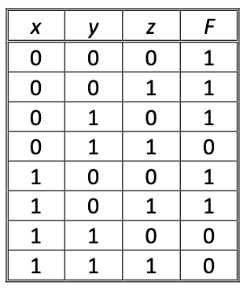

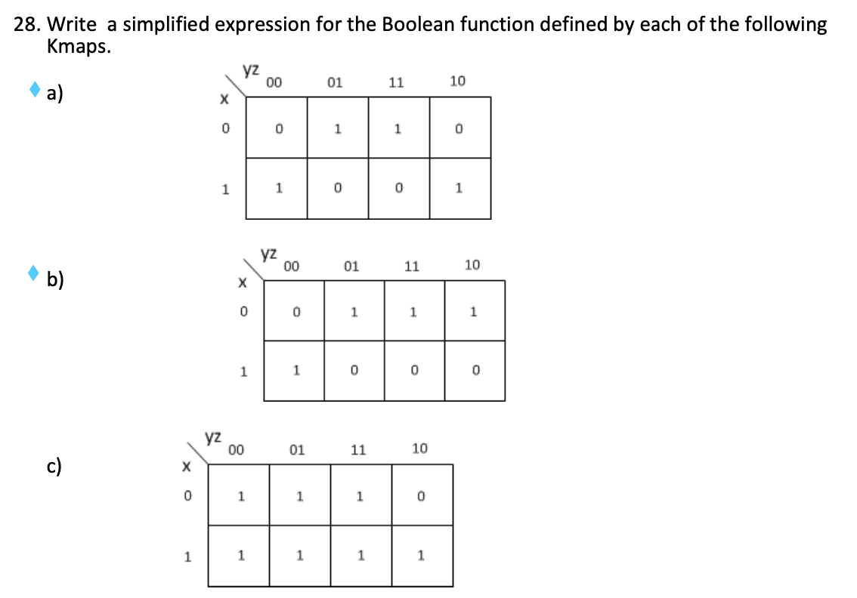

A answer)

B answer)

C answer)
29. Write a simplified expression for the Boolean function defined by each of the following Kmaps.
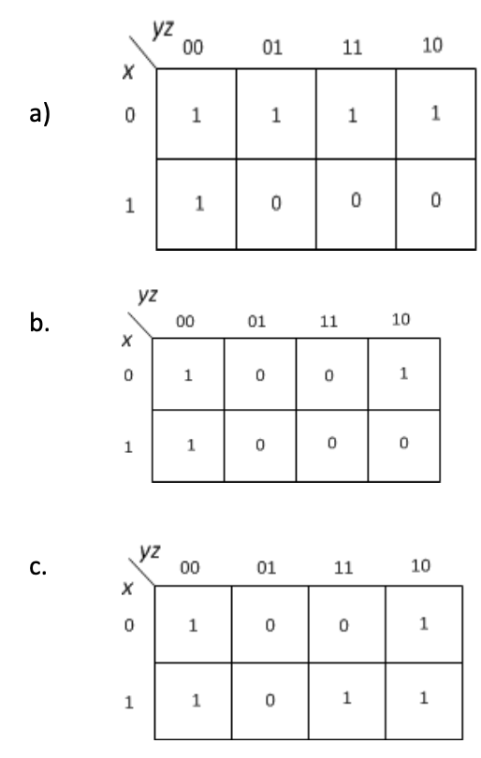
A –

B –

C –

31. Write a simplified expression for the Boolean function defined by each of the following Kmaps.
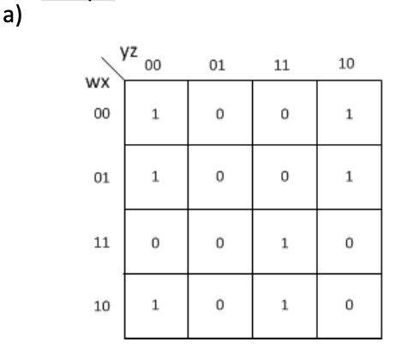
A answer :
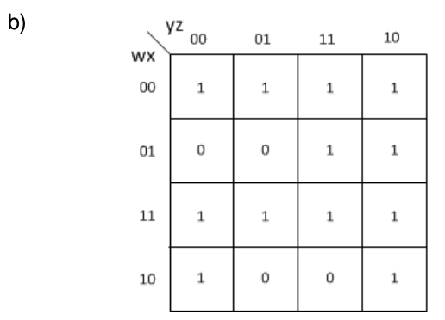

B answer :

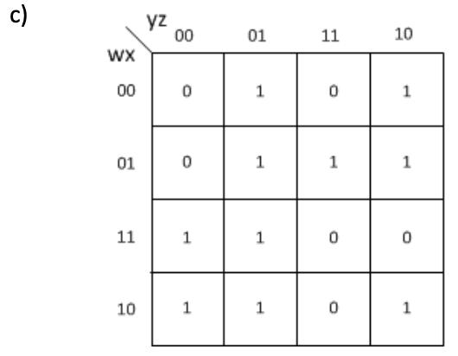

C answer:

34. Create the Kmaps and then simplify for the following functions (leave in sum-of-products form):
- a) F(w,x,y,z) = w'x'y'z + w'x'yz' + w'xy'z + w'xyz + w'xyz' + wxy'z + wxyz + wx'y'z

- b) F(w,x,y,z) = w'x'y'z' + w'z + w'x'yz' + w'xy'z' + wx'y

- c) F(w,x,y,z) = w'x'y' + w'xz + wxz + wx'y'z′

